Tri Living Well

TLW Marketing Website and TLW Client Service Site

Functional Specification

Date: 3/18/2010

MODIFIED October 28, 2010 BY TLW

**Introduction – Goals of the System**

**GOALS AS STATED BY TLW –**

Overall goal of system is to easily ramp users on to a web services platform that will allow users to adopt a healthy lifestyle and measure their success towards that goal.

TLW believes the key elements to accomplish:

* Creation of fitness programs incorporating a variety of ability and health levels
  + So that a user can participate regardless of current health
  + Workout plans that are user selected based on interest
  + Displays/shows to users an exercise pattern – regimented program with benefit of knowledge /expertise of personal trainers
* A variety of nutrition information tied into fitness that:
  + Provides Education – shows users how to eat healthy
  + Summaries of meal plans, recipes and educational articles that can easily be printed, downloaded, etc.
* Weight/waist measurements / BMI / Body fat are key data points to help users measure effectiveness of nutritional program. Metabolic minute accumulation and calories burned assess personal fitness.
* Reporting capability to users and companies who sponsor help measure effectiveness, such as:
  + FOR COMPANIES FOR EMPLOYEES
  + Participation, Users, activity Key data points – weight, bmi, body fat
  + # Of fitness activities by type, week Average weight loss
  + METS by user, overall

Reporting elements are used as an example, and should be defined based on system capability

**OVERVIEW**

TLW wants to complete the development of a membership-based website which currently exists as a partially completed product. Development initiated on the current system (hereafter referred to as “My TLW - Version 1”) based on requirements of the TLW Client Service Site, however, there are several areas of development which need to be completed before a final, functional system can be ready. The marketing home page will also be the entry point for client end-users who have an account on the “My TLW” site. The “My TLW” site needs to have only a minimal degree of branding customization built into it, mainly for customization for display of specific client logos and/or messaging, link to intranet if applicable etc.

In their statement of goals for this system, TLW said they want to give the users visual validation that they are making progress on each of the three main categories of interest, namely: (1) Nutrition, (2) Exercise and (3) Wellness. Also, they want to motivate people and groups based on performance metrics (i.e. graphic display on dashboard), and perhaps even incentivize users based on meeting or exceeding their performance goals.

The ultimate goal is to offer a package for exercise, nutrition, wellness (overall health tracking), supported by the “My TLW” website. Wellness is defined (by TLW) as sleep, stress, general outlook, etc. They want to roll these three health metrics into a single, comprehensive web application. TLW wishes to sell this system to companies that provide insurance -- or which self-insure -- and have a large number of covered individuals. TLW intends to sell to HR departments or presidents/CEOs directly depending on the size of the company. The objective is to foster better morale and satisfaction from “My TLW” members. As a result, the system could be used as a way of reducing costs and increasing productivity.

1. **Objectives of this Document**

This document is intended to define the efforts and scope for completion of the “first” phase of the online service to be offered by “Tri-Living Well”. This is effectively a “path to completion” that supersedes any previous end-product expectations. It will include:

1. **Algorithms and processes (what each section of the site/service does and how it works)**
2. **Functional screen designs (screens that will be used in the final programming)**
3. **Features**
4. **Recommended testing procedures during and at the completion of programming**
5. **Gant chart inclusive of milestones and deadlines**
6. **Break-out of all expected costs**
7. **Existing System - The Basis for Functionality Moving Forward**

For the purposes of this specification, the existing website will provide the basis for expected functionality moving forward. There is limited to no existing functionality that TLW can take advantage of currently. While development work has taken place, the company currently does not have a functioning prototype or product. This functional specification will document proposed changes from the existing development work, and functionality, as well as how we will proceed.

1. **TLW Marketing Website and TLW Client Service Site (“My TLW”)**

The TWL Marketing website refers to the publically available home page at <http://www.tri-livingwell.com> and <http://www.trilivingwell.com> which will be used, presumably, to market the sale of the Tri-Living Well service. The TLW Client Service site refers to the website into which all of TLW clients’ users log in. Throughout this document, we will use the designation “My TLW” to refer to this latter website. The “My TLW” site content and functionality are context-sensitive based on the Client End-User login profile and, in the case of the logo, the Client Company.

Since Tri-Living Well’s business strategy is based on the objective of selling their system to large companies – which will then encourage their employees to use it – it is assumed, for the purposes of this document, that most users will be associated with a Client Company (i.e. that TLW’s customers will NOT be users who wander in from the web and create single accounts). As a result, we will often refer to the end users as Client End-Users.

**TLW Marketing Website – The existing public page is based off of this original design**



**B**

**A**

Flash movie will loop through 3-5 images purporting the benefits of the TLW web service.

The content of the various web pages in the TLW Marketing website will be provided by TLW early in this project. This site will be primarily static. Except for section “A” and “B”. These sections will allow for editing by TLW personnel.

1. Home page– this will tell visitors:
   * What the site does, how it works, sites purpose
   * Who the site is for – should you be interested
   * Features, benefits, mission
   * Navigation / login for site
2. About Us – This will tell visitors
   * Who TLW is, credibility, why we do what we do
3. How it Works
   * What the site does
   * Features
4. Why use us (not shown – added)
   * Advantages of using us when trying to improve lifestyle
5. Contact us
   * Contact information – email, phone?, address?
6. News and announcements
   * Same as on client end-user site
   * Could include news feeds
   * Will have a back office utility that allow for the addition of text to be cut and pasted, or a URL that will open in a pop-up window
7. Login / Registration – similar to from old system
   * Users log in
   * New users – register (pre-registered only)
   * Forgot password utility

Homepage

About us

News &  
announcements

How to get  
Started

Why use  
us

How it Works

Contact   
us

Email Form

Contact info.

Why Wellness

Fitness

Nutrition

* Bottom image will loop through a series of images and text. Each image/text combo has an exclusive link.
* TLW email will go to static address
* Navigation to “fitness”, “Nutrition”, and “Why Wellness” from main menu is via top images

**Editing screen -** administrators will be able to edit the middle two section of the home page (“tri-living” and “Well”) as well as news and announcements.

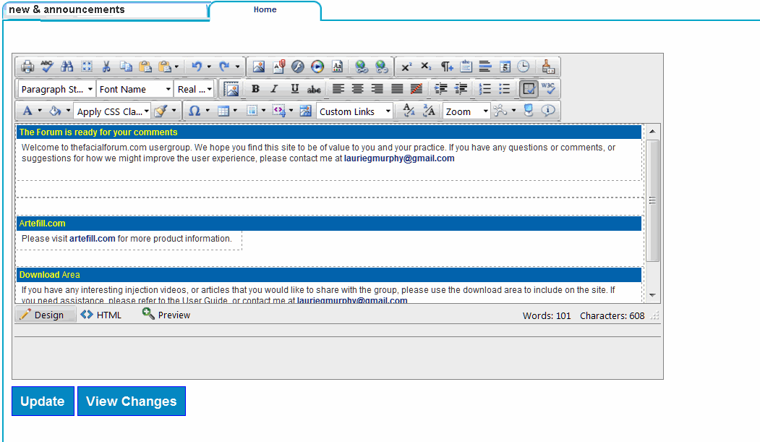

Typical editing screen

**V. TLW Client Service Website (“My TLW”)**Registration – Prior to usage, the user must first register. This process will involve a “stratification” process that will be used to assess the current level of fitness, and serve as a starting point for recommending programs regarding caloric intake/diet (nutrition) and exercise regimen (fitness).

During this registration process we also intend to provide information about the program including how to use it, and what the various fitness/nutrition levels mean.

In order to qualify for registration users must belong to an organization that has ordered the TLW service. This means that they will have been added to the site as part of a list of “approved users” and will be given registration with temporary password that will allow them to initiate the registration process. Although not included in the first version deliverable, subsequent versions will include the ability for TLW personnel to add a list of people when adding a new corporate client (and ability to automatically notify them via email of the user id and pw).

**FUNCTIONALITY HAS BEEN FURTHER DEFINED IN DOCUMENT TITLED**

**FUNCTIONALITY STREAMLINED 050510**

*Development Note 10 -28 -10 – The Functionality document that I sent to you previously is how TLW wants the process for new users to be implemented. The risk stratification listed below has been streamlined and is superceded by Functionality document already in the hands of Netsmartz.

**Risk Stratification**

Since users will be pre-registered in terms of entry into the system, we will conduct the questionnaire from within the “my TLW” site. Also, in the event that pre-registration does not include the users name, we will give them a chance to enter their name, email address, etc. in the first screen.

2

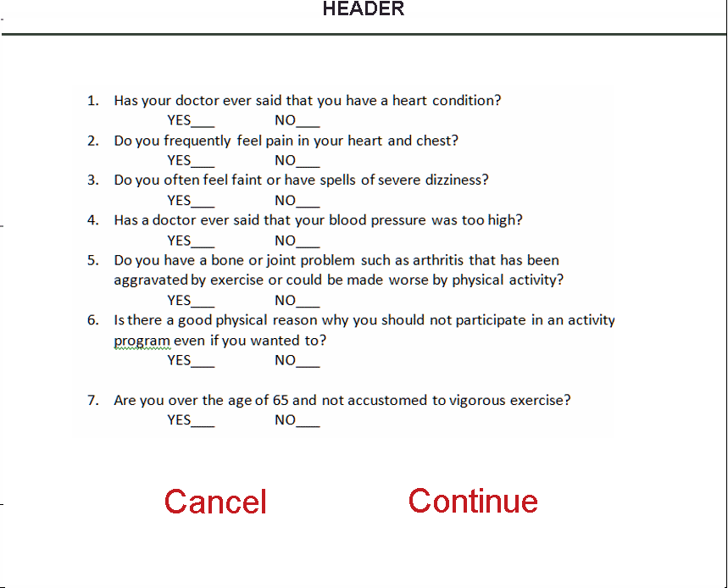

4

5

1

3

**FUNCTIONALITY HAS BEEN FURTHER DEFINED IN DOCUMENT TITLED**

**FUNCTIONALITY STREAMLINED 050510**

**Risk Stratification**

Depending on how the registrant responds to the questionnaire, they will either continue to the “how to use” portion of this process or be given more questions.

Medium Risk

Low Risk

Tri Level Walking

only

Tri Level

Walking

Strength Training

Swimming

only

Number of CVD Risk Factors

< 2 risks 2 or more risks

Major Signs or Symptoms Suggestive of CV, Pulmonary, Metabolic Disease

If No If Yes

Known CV, Pulmonary, Metabolic Disease

If No If Yes

Risk of Metabolic Syndrome

2 or less 3 or more

Physical Activity Readiness Questionnaire

If No If Yes

Tri Level

Walking

only

Tri Level

Walking

Strength Training

Swimming

only

Framingham Heart Risk Study

10 – 20% > 20%

High Risk

The rest of the forms/questions are contained in appendix A

**?? USER SHOULD BE GIVEN A RESULT – IE TRI/LIVING/ OR WELL LEVEL – INDICATING WHAT THEIR RESULT WAS FROM TAKING THE SERIES OF QUESTIONS – AND AN EXPLAINATION OF EACH LEVEL ??**

**After stratification – user should be given a result – ie based on your answers to our questionairre – users are informed they fit into one of 3 fitness levels: TRI, LIVING, or WELL.**

**A brief explaination of each level is provided (Brian has details) – ie each level has a criteria of how many times a person can perform physical activity, etc…**

**NEXT – need the user to acknowledge a waiver and indemnification.**

**<NOTE> Waiver and Indemnification**

Regardless of level of activity, or where a person is slotted, user must acknowledge the read, understanding, and receipt of a waiver. (give an option to print for records, etc…)

For example, this is the waiver terminology specific to nutrition: - we may want to put as a footer to every nutrition page

Please note that some foods may not be suitable for some people and you are urged to seek the advice of a physician before beginning any weight loss effort or diet regimen. Although the information provided on this site is presented in good faith and believed to be correct, Tri Living Well, Inc. makes no representations or warranties as to its completeness or accuracy and all information, including nutritional values, is used by you at your own risk. All trademarks, copyright and other forms of intellectual property are property of their respective owners.

**Learn and Choose <Change> Choose Your Fitness Program**

After the Stratification process, the user will continue. User will be prompted to select an activity based on their interest, or what activity they will be able to start.

Swimming

in rutrum gravida, justo arcu facilisis purus, vel feugiat mauris nulla id mi. Maecenas rutrum commodo est, ac scelerisque nibh luctus a. In hac habitasse platea dictumst. Vestibulum fringilla lobortis gravida. Fusce mattis, lorem vel euismod pharetra, neque est lobortis eros, varius ultricies tortor ipsum sed felis.



This section will provide a summary overview of the 9 physical activity programs so that the user can make an informed decision to choose what program is best suited for them. The user can click on the graphic representing the specific activity program.

There will also be a guide that suggests an activity program based on the current health status of individuals. NOTE: individuals will not be selecting their program at this level, we are not sure why it is referred “learn and choose”. ?? WHY CANT USERS SELECT ??

Note at bottom – users can change or opt out within the 1st 3 weeks if the program is not meeting needs of user, etc…

<note> Not a guide. Users will have choice of programs. If a person, based on their answers, shows a sedentary lifestyle, they will have a suggested list of programs.

<note> If assistance is needed – provide link to “Ask the Health Coach” – link to [coach@trilivingwell.com](mailto:coach@trilivingwell.com). If you need help with choosing a program, what program is best for a participant, questions about physical activity, questions about what each level or type of fitness program, etc….

Next step = Explanation / Introduction to Nutrition

Brief description of Nutrition programs, what’s intailed, what the nutrition section is, etc…

Part of the section Is to select a calorie range –

How to –

User inputs age, weight, and height

Calculator presents you a base rate –

Next step is user is given 5 choices for activity factor based on current health from extremely active to sedentary.

Brian has calculations to provide to Blue Grotto.

Calorie range goes into dashboard.

Fitness level goes into dashboard.

- User is sent to the tutorial section -

**Tutorial** XXX <Change> example – User Education and Advice??

This can be laid out in a way similar to the “learn and choose”. In this step the user will learn all about the various terms and activities within the TLW web service.

<NOTE> this is not about terms and activities

Section is user education and advice:

1. Info on goal setting, rewards, and objectives.
2. Common Terms – How users are measured, different levels of intensity
3. How we measure (METS) - <note> we are staying away from description of mets or metabolic minutes but are trying to explain the goal to aim for.

METs

arcu mi. Integer quis est lectus, at malesuada urna. Aliquam ultrices, leo in rutrum gravida, justo arcu facilisis purus, vel feugiat mauris nulla id mi. Maecenas rutrum commodo est, ac scelerisque nibh luctus a. In hac habitasse platea dictumst. Vestibulum fringilla lobortis gravida. Fusce mattis, lorem vel euismod pharetra, neque est lobortis eros, varius ultricies tortor ipsum sed felis.

What are METS

Levels of  
Intensity

Goals &   
Objectives

Next

< NOTE > USERS SHOULD BE GIVEN AN OPTION TO OPT OUT OF THE INTRODUCTION / TUTORIAL SECTION OF THE WEB SITE AND PROCEED RIGHT TO PROGRAM SELECTION

(NO) XXXXX OUT After the tutorial, the users will choose their programs (including their preferred methods) for exercising and diet goals.

Fitness  
 - Exercise Selection  
 - Desired Intensity

Nutrition  
 - Goals and obj.  
 - Calculator

Program Selection

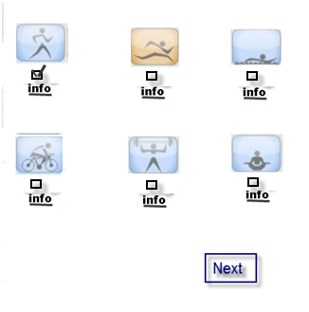

In this step, the user will select their physical activity program at the proper level. They will then be guided to Nutrition. A guide to Nutrition will explain how the Nutrition plan works and instruct the user to the Nutrition calculator, where they have the option of calculating a calorie range or opting to select number of calories.

Fitness  
 - Exercise Selection  
 - Desired Intensity

Nutrition  
 - Goals and obj.  
 - Calculator

Program Selection



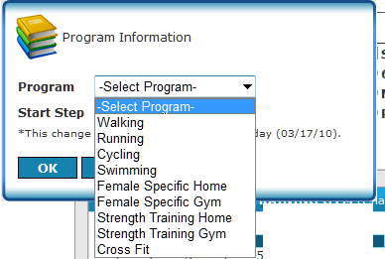

Fitness  
 - Exercise Selection  
 - Desired Intensity

Nutrition  
 - Goals and obj.  
 - Calculator

Program Selection

What do you want to accomplish?

Maintain Weight ___

Gain Weight ___

Lose Weight ___

Fitness  
 - Exercise Selection  
 - Desired Intensity

Nutrition  
 - Goals and obj.  
 - Calculator

Program Selection

Current Weight:

Height (inches):

Activity (intended):

_ sedientary _ Lightly Active _ Moderatley Active _ Very Active _ Extremely Active

Formula for Basic Metabolic Rate:

We have to decide what percentage of the BMS caloric intact as a function of the nutrition goals.

*Basic Metabolic Rate*

Women > BMR = 655 + (4.35 x weight in pounds) + (4.7 x height in inches) – (4.7 x age in years)

Men > BMR = 66 + (6.23 x weight in pounds) + (12.7 x height in inches) – (6.76 x age in years)

*Resting Metabolic Rate*

Women > RMR = (9.99 x weight in kilograms) + (6.25 x height in centimeters) – (4.92 x age) – 161

Men > RMR = (9.99 x weight in kilograms) + (6.25 x height in centimeters) – (4.92 x age) + 5

Current weight ___divide by 2.2 = ___ kilograms (kg)

Current height ___multiply by 2.54 = ___ centimeters (cm)

The BMR and RMR represent resting energy expenditures. However, in order to calculate your total daily energy expenditure (calories) an activity factor is applied.

Activity Factor Category Definition

1.2 Sedentary Little or no exercise

1.375 Lightly Active Light exercise/sports 1-3 days/wk

1.55 Moderately Active Moderate exercise/sports 3–5 days

1.725 Very Active Hard exercise/sports 6-7 days/wk

1.9 Extremely Active Very hard exercise/physical job, training 2x daily

**How to use Program**

In this section, the new user will be able to view how to use the site. The demo/tutorial will incorporate how to use the Nutritional Journal, Physical Activity Log, Daily Diary and Forum section.

Registered users should be able to log back onto this section to review if needed.

After this point – the user will begin using the program.

**DASHBOARDS HAVE BEEN FURTHER DEFINED IN DOCUMENTS:**

**MY DASHBOARD – PERSONAL FITNESS**

**MY DASHBOARD - NUTRITION**

**MY DASHBOARD – WELLNESS**

MY TLW

|  |  |  |  |  |  |  |  |
| --- | --- | --- | --- | --- | --- | --- | --- |
| HEADER | | | | | | | |
| Nutritional  Center  Daily Diary  Meal Exchange (KW)  My Nutrition | | Personal Fitness  icon for fitness.gif  Activity Log  My Program  Help change goals | | | Wellness Diary  wellness.gif | | |
| Newsletters  Current  Library  TLW Forum | What’s Hot | | | | | | |
| My personal.. (or My Program? KW) | | | | | | |
| Facebook  Twitter  Blog | My program  (KW - Icon) | | My nutrition  Recalculate  (KW - Icons) | Activity calendar  (KW - Calendar Icon – Month w/breakout day) | | Meal Exchange  (KW - And other options?) | |
| Note: see artwork of site in appendix B | | | | | | |

**<note> Need to ask – original “spec” meeting was that users could enter their nutritional AND WELLNESS INFO RIGHT FROM THE HOMEPAGE/DASHBOARD. FITNESS WOULD TAKE USER TO ACTIVITY LOG TO COMPLETE RECORD.**

**A. Nutrition Center ( see top – says Nutritional?)**

The Nutritional Program is intended to: 1) Suggest a diet based on the users goal, objectives and metabolism; 3) provide information about different food products and groups; and 2) allow users to log, track and display information about their caloric consumption. The pyramid will display the recommended levels/portions for each food group (protein, fat, fruit, etc.) – **BASED ON RECOMMENDED CALORIE/CALORIC INTAKE**

NOTE – FOOD JOURNAL IS NAME FOR ITEM – XXX DAILY DIARY. When the user clicks on “Daily Diary” they will have access to their intake diary which will be pre-filled with the suggested intake as default parameters. From this they will be able to confirm or change those parameters. We suggest this diary goes into the center of the page. The diary will also allow for a “quick” confirmation entry – “how did you do with your exchange”.

MEAL EXCHANGE DOES NOT NEED TO BE IN THE DASHBOARD SECTION. USERS WILL SEE THIS ONCE THEY ACCESS THEIR FOOD JOURNAL. OR FOOD LOG / JOURNAL A BETTER NAME?

When the user clicks on the actual pyramid or “My Nutrition” they will see their recommended diet. In this case the entire page will be replaced.

MY NUTRITION WOULD SHOW A PERSONAL SUMMARY – IT WOULD INCLUDE:

START DATE TARGET DATE

START WEIGHT TARGET WEIGHT WEIGHT LOSS/GAIN GOAL

START BMI TARGET BMI BMI DIFF

START BODY COMP TARGET BODY COMP

1ST TIME USER WOULD BE SHOWN – CALCULATE YOUR IDEAL HEALTHY WEIGHT RANGE (Brian has another formula based on body fat/ideal range based on height, etc…)

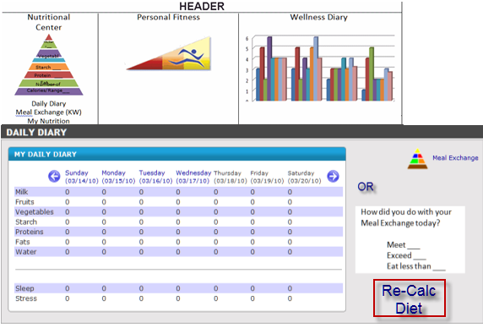

Daily   
Diary

We may want to allow for a “weekly” confirmation

WE WANT OPTION FOR JUST SHOWING A DAY AS A DEFAULT – WITH AN ABILITY FOR USER TO SELECT A “WEEKLY” VIEW.

Note: user will be able to re-calculate his diet (same as during registration)

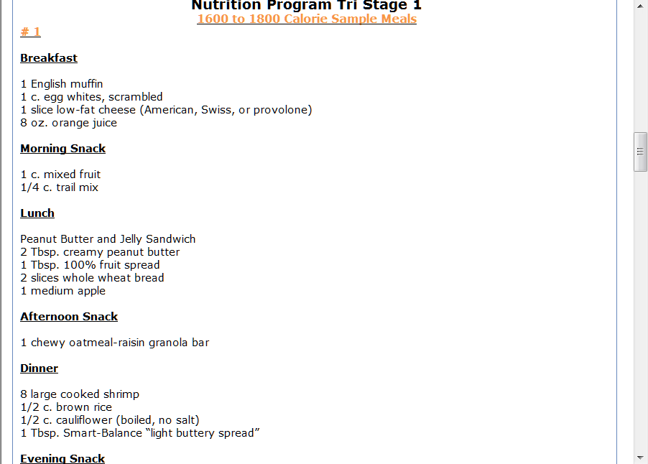

Nutrition Menu  
when user  
Clicks on   
Pyramid or “My Nutrition”

When the user clicks on “meal exchange” in the upper left corner, the meal exchange menu will replace the main window. This will also occur when the user clicks on meal exchange from the bottom menu (in the box on the lower right corner) or when user clicks on “nutrition details from within their “menu”.

NOTE: need to consider a new term for Meal Exchange. Some being considered are: 1) Meal substitution table 2) Nutrition equivalents.

Header

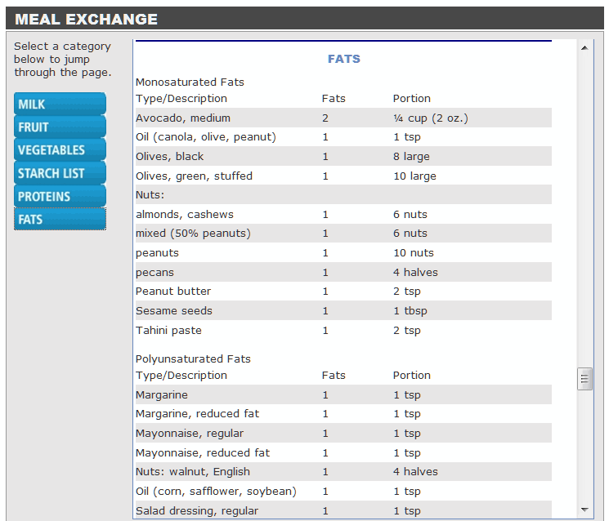

We may want to determine if a better interface for the meal exchange module would be beneficial to the look of the site. This could include doing the module in flash, or adding icons to the navigation labels on the left (i.e. a “cow” image for milk, Steak, eggs for protein, etc.).

**B. Personal Fitness (top center)**

Similar to the “Nutritional Center” the personal fitness utilities will aid the user in: 1) selecting exercise; monitoring their exercise; 3) providing instruction on exercise, 4) and displaying how well they are maintaining their program.

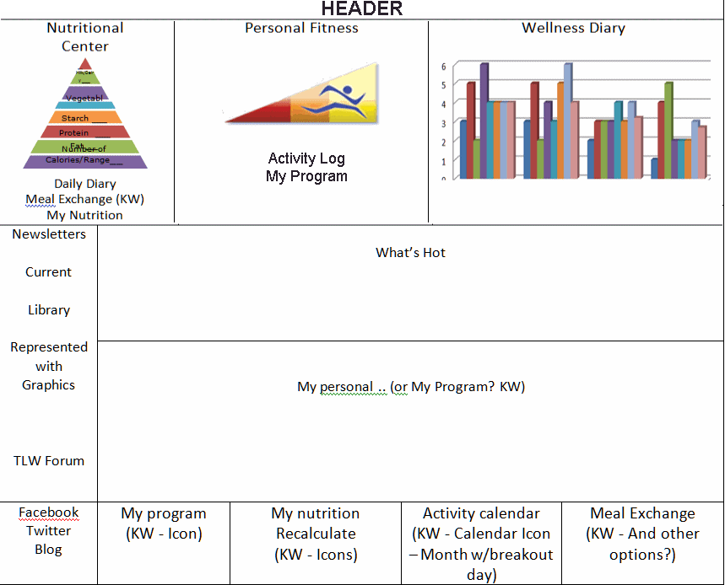

The Tri-living well icon is going to indicate the MMETS (weekly metabolic minutes) of the user. The runner will be at different parts of the triangle depending on the physical activity level. When they click on this Icon they will be taken to their Personal activity log (likewise if they click on the bottom square -2nd from the right). This log will replace the entire page (except header) and contain the same navigational options as is in the current site.

If the user clicks on “my program” they’ll be presented with information regarding their fitness regimen. This will fill in the entire frame (except header).

Note:

1. We need to be provided the method for calculating METS
2. The data regarding the MMETS will be based on a six month period starting (backwards) from the most recent data entered. ??need to flush out more??

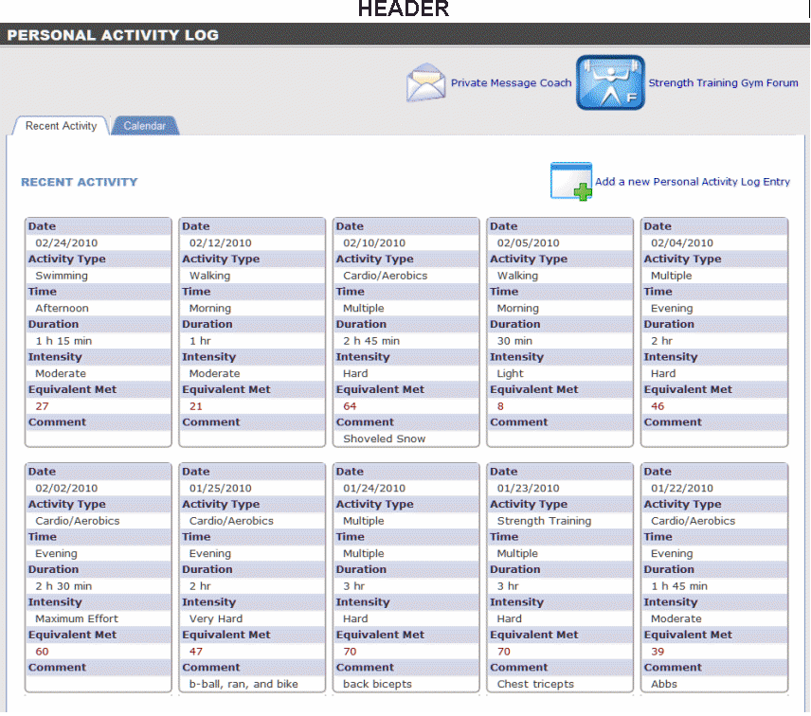

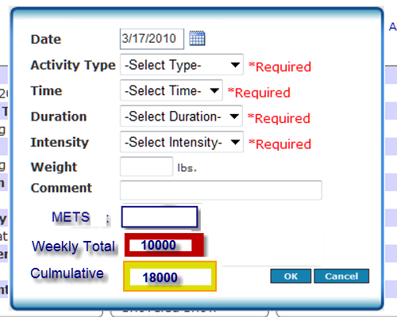

Activity Log  
*w/ entry screen*

NOTE – the pop up menu needs to be designed to look more user friendly – looks thrown together right now.

The parameters entered are the same as the current system collects, however we want to show METS (need to find how/if this is calculated). The weekly totals will show a color depending on level of activity (could be box outline)

Tri color 0 – 500 METs

Living color 500 – 1000 METs

Well color 1000 +

At the end of the user’s 6-month program, the user will be rewarded based on the following categories:

Gold 13,000 – 19,500 METs

Platinum 19,500 – 26,000 METs

Crystal > 26,000 METs

??? – need to flush that out – what do the rewards really mean??

These colors can be shown in the cumulative box after six months and will indicate the previous 6 months of activity, from the most recent entry to the journal.

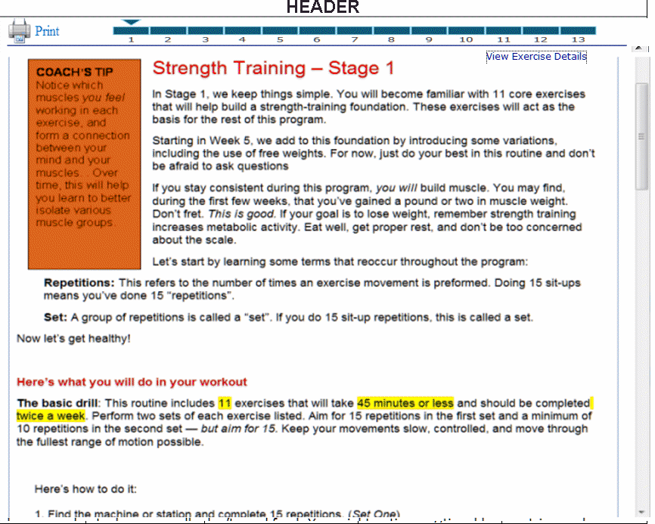

THIS LAYOUT NEEDS TO BE SIGNIFICATLY REVISED. CURRENT FORMAT IS ALL INFORMATION THROWN TOGETHER ON ONE PAGE – DOES NOT READ OR PRESENT WELL.

My Program

From the “my program” screen, the user will be able to see program details (instructions on specified exercises) – this will be a pop-up. From the center “fitness” Icon the user will also be able to click on “help” which will take them to the forum. The “change goals” button will place a form on the page that will allow them to change their program.

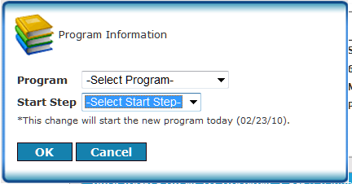

?? HOW DOES A USER CLICK TO THEIR PERSONAL ACTIVITY LOG FROM THE DASHBOARD ??

**Wellness Program (top right box)**

This box is going to graphically show the wellness condition of the user. As they are already capable of entering the detail necessary to create this chart/graph, clicking on it will only expand it. Some ideas for displaying it are still being reviewed.

One aspect of this section is the suggestion that when we click on the square (upper right most corner) it displays within home page (frame).

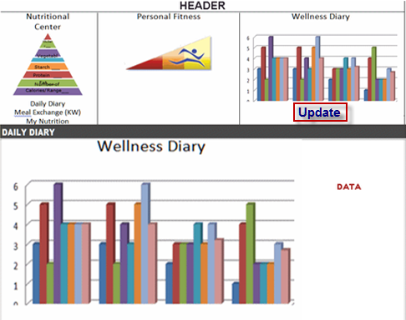

Potential concept for  
display of “Wellness Information”.

Note the data area to the right

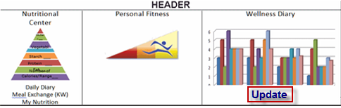

|  |  |  |  |  |  |  |  |  |  |  |  |
| --- | --- | --- | --- | --- | --- | --- | --- | --- | --- | --- | --- |
| Sleep | For  Day | For Week | Stress | For Day | For  Week | Outlook | For Day | For  Week | **Engagement** | For Day | For  Week |
| Very poor |  |  | Extremely |  |  | Pessimistic |  |  | Negative |  |  |
| Poor |  |  | High | X |  | Distressed |  |  | Somewhat Neg |  |  |
| Fair |  | x | Some |  |  | Concerned |  |  | Average |  |  |
| Good |  |  | Moderate |  |  | Hopeful |  |  | Somewhat pos. |  |  |
| Very Good |  |  | Low |  |  | Optimistic | X |  | Positive | X |  |
| Excellent |  |  | Very low |  |  | Excited |  |  | Very positive |  |  |

For quicker entry of our “wellness” parameters, we suggest giving members the option of characterizing an entire week.

<note> NOT SURE OF ENTERING IN WEEK AS A CONCEPT – DEFEAT PURPOSE OF USAGE AND MAY “TARNISH” INFORATUION PROVIDED BY USERS??

?? NO VALUE FOR WEEK – WE PRESENT DATA BASED ON THE WAY IT IS ENTERED ?? GO BACK TO THE LAST 5 ENTRIES OF “DAY”?? VS LETTING USERS ENTER A WEEKLY RANGE

**TLW Forum**

The forum is used to allow members within an organization to communicate and support amongst each other (as well as receive expert support). We will create pre-populated categories where they can post questions, or search the questions and comments of others. Some of the features contained in the forum will include the ability to “Watch / subscribe” to a thread. This feature enables the user to be notified immediately (vai email) anytime someone comments on, or adds a posting.

Currently the forum is categorized by exercise, and within exercise, level. We are suggesting that level be removed. We thought it could be a benefit for a beginner to see what type of issues/concerns or problems are being encountered by more experienced members of the site. However, we may wish to consider adding section within an exercise category such as: tidbits & suggestions; injury and avoidance; MMETS and technical questions; all else.

We suggest that after the forum gets use, we review the content and determine how best to categorize questions/comments.

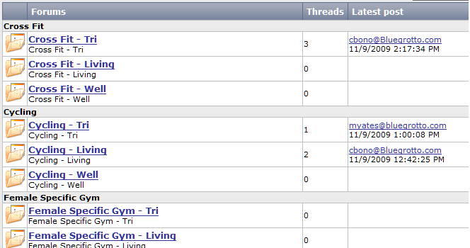

Current Forum  
Organization

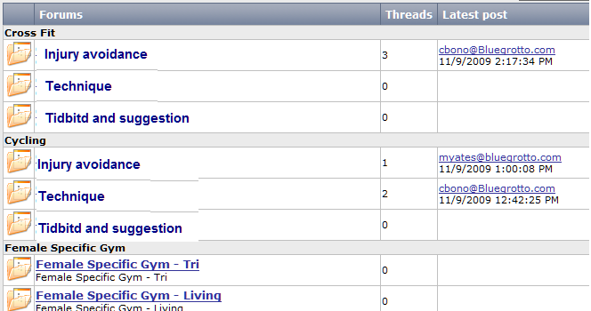

Suggested Forum  
Re-organization

New Organization

**Newsletters** – when the user clicks on this, they are going to see the various newsletters with “description” to the right. They will be able to click on a newsletter and a pdf will open with that Newsletter.

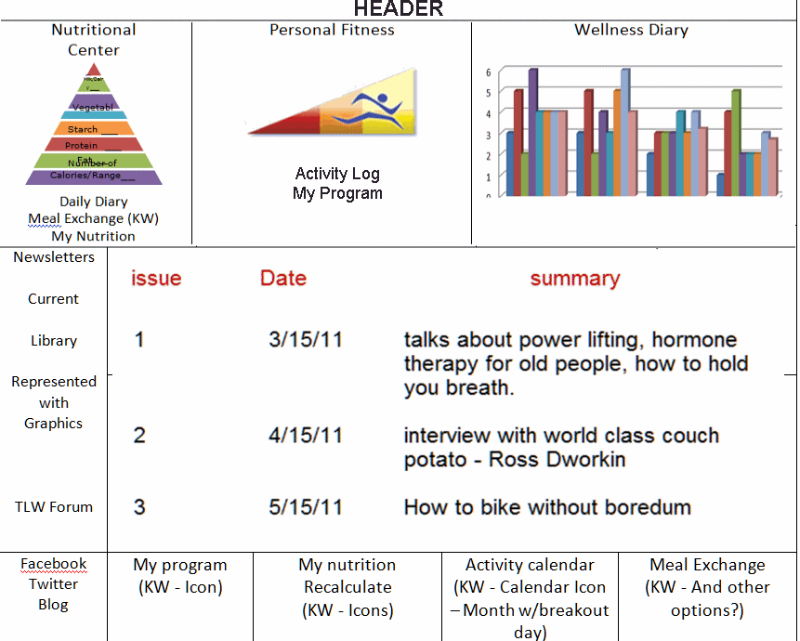

**Newsletter selection**Note: Newsletters can be added, with description by TLW personnel

**Events** – this will contain a list of events in the area for the user. We think users should eventually be able to submit events to be shown to everyone in their organization. Events submitted by members will not be visable until TLW personnel approve the event.

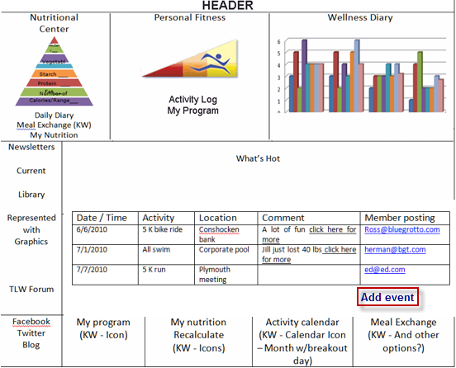

Note: button should really read “submit event”

The add event button won’t actually add the event; it will forward it to TLW personnel. They will add the event (by approving it).

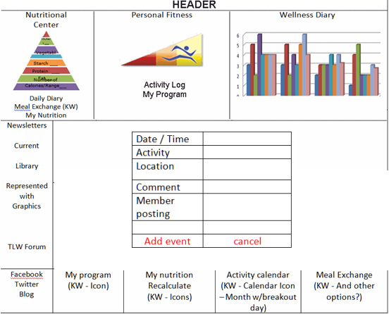

**Library** – This will contain information/content inserted by TLW personnel that should be of value or interest to member. Members will view a list of assets (content) and their description. If a user wishes to access information then they will click on the item and it will appear in a pop-up window.

The information in this section can be the URL of a website or a pdf in which case a window will pop-up. The information can also be a document (pdf, ppt, image); which will also be opened in a “pop-up” window. TLW personnel will be able to add content. For our first deliverable (version 1.0), the window will scroll up and down, and the content will just in the order indicated by TLW personnel.

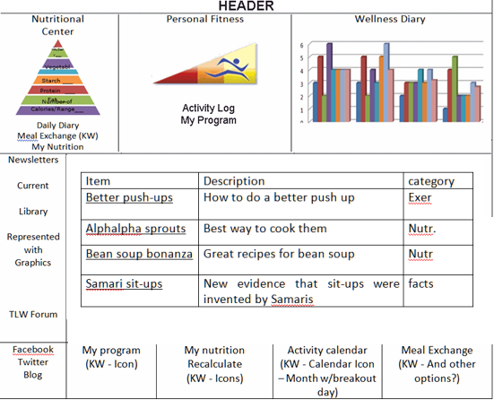

**Managment Utilities**  
This section will define and describe what back office utilities will be included in the first version of this software. These utilities can be characterized as follows:

* Content management / content loading
* Administration utilities – email
* Reporting/usage statistics

Note: this section does not include the administrative tools necessary for the corporate site.

**Content management**  
this section of the document will address those sections that require modification by TLW personnel.

Newsletters

The newsletters are expected to be PDF’s. the Webmaster will add a new newsletter by entering a title, entering a description, then uploading it. The webmaster will also be able to remove the link of previous versions. In this version we expect to use a scroll bar as the number of newsletters increase. In the next version we’ll add pagination.

|  |  |  |  |  |  |
| --- | --- | --- | --- | --- | --- |
| Administrative tools | | | | | |
| Newsletter add | Title  Description:  Date:  Upload  and add  C:\p.pdf  Browsed  Delete  Newsletter one | | | |  |
|  |  |
|  |  |
|  |  |  |  |  |  |

Note: to delete a newsletter, select it from the drop down then click on delete.

LIbrary

The library will work almost identically to the Newsletter cms, however it will allow for the referencing of other websites/urls, as well as the uploading of non-pdf documents.

|  |  |  |  |  |  |
| --- | --- | --- | --- | --- | --- |
| Administrative tools | | | | | |
|  | Add new item | | | |  |
|  |  |
| Content Library |  |
|  |  |  |  |  |  |

If the webmaster chooses to add a new item then they will get the following screen (if they click on edit they will get the same screen but with the fields filled in).

|  |  |  |  |  |  |
| --- | --- | --- | --- | --- | --- |
| Administrative tools | | | | | |
|  | Title  Couch potato s..  Date:  3/18/2010  Description:  Aenean vel est sapien, sed hendrerit odio. Integer feugiat vestibulum massa, quis ullamcorper dolor interdum ac.  Upload  and add  Browsed  C:\p.pdf  Cancel  Update  Link  URL: | | | |  |
|  |  |
| Contact Library |  |
|  |  |  |  |  |  |

Event Calendar  
The system will allow the webmaster to modify events listed, add new ones, and ok events that were submitted by users.

|  |  |  |  |  |  |
| --- | --- | --- | --- | --- | --- |
| Administrative tools | | | | | |
|  | Add event | | | |  |
|  |  |
| Event Calendar |  |
|  |  |  |  |  |  |

Approved means that the event will show up in the users list. When a member submits an event, it will show up on this table for approval.

|  |  |  |  |  |  |
| --- | --- | --- | --- | --- | --- |
| Administrative tools | | | | | |
|  | Add event | | | |  |
|  |  |
| Event Calendar |  |
|  |  |  |  |  |  |

When the user clicks on “edit” in the event table, they will get a form enabling them to modify event information.

What’s New  
There will be an editing / updating utility for this section of the site. It will be identical to the one on the corporate site.

**Administrative utilities**The system will allow TLW personnel to perform basic management functions. Most of these features are standard so we will not give detailed operations

* Add Users
  + Ad users for a company (for the first deliverable, BGT will have to add new organizations)
  + Modify / Delete users
  + Automatically notify users of logon information
* Send Email
  + To everyone in a company
  + Individual users
  + Users selected via specific criteria (tbd) can include:
    - MET, level
    - Gender, age
  + Templates
    - Pre-formatted and worded emails (assume 4)

Reports

**TBD** – we’ll assume up to for reports, including:

* Company/organization usage
* Individual usage (sortible and filterable by basic characteristics i.e. gender, age, level)
* Change in level / health characteristics
  + By organization
  + For specified user

**VI. Development Schedule**

This section will identify most of the tasks required to complete the first version of this web site and estimate the schedule, relative to the start, of these tasks.  
  
**Corporate Website  
Approve artwork / graphics** – determine the final look and feel regarding graphics, colors and “header”.

**Layout site** – Create home page and all associated sections of the site.

**Insert content** – Insert content into site

**Flash program** – create the sequencing flash program for the home page

**Content management system (CMS)** – create back office utility to modify the “What’s New” section of the home page and insert news headlines.  
 **MY TLW Site  
Create new branding** – This refers to the new colors, images and general changes to “look and feel”.

**Modify site structure** - as defined by the navigation contained on the home page. Apply new home page graphics.

**Registration** – create program as defined above. Make modular to allow for re-use of portions required for established users (nutrition calculator, exercise information, etc.)

**Create sub programs** – this would include the nutrition center, personal fitness and wellness diary. Much of these programs have been created but need to have the new artwork applied to them, as well as have elements launch in a different way (i.e. main window vs. pop-up).

**Navigation of sub programs** – Link sub programs from main navigation points of home page (top), as well as outer page boxes.

**Create non-primary programs** – This would include: Library, event system and forum. Many of these programs are completed and only need to be re-branded (colors/ new artwork).

**Program Layout** – We need to layout many of the programs in both nutrition and exercise into an HTML format compatible with most browsers.

**Navigation to non-primary programs** – link to these programs from the homepage.

**Create CMS interface** – Create the content management utilities necessary for TLW personnel to manage the site, including:

* Home page (what’s new)
* Events
* Library
* Newsletters (same as corporate page)

**Administrative tools** – For first version deliverable we will include email utilities with: Templates and selection filters. We will also create and install “member utilities” (i.e. add/delete members).

**Reports** – as defined above

**Weekly reviews** – the team, inclusive of TLW personnel and BGT program management will need to review progress and site operations on a weekly basis.

Approximate delivery schedule  
The following timelines assume that content will be available when required by Blue Grotto Technologies, Inc. Work on corporate website and “My TLW” site will overlap.

**Corporate Website**

|  |  |  |  |  |  |  |  |  |  |  |  |  |
| --- | --- | --- | --- | --- | --- | --- | --- | --- | --- | --- | --- | --- |
| **Task/week** | 1 | | 2 | | 3 | | 4 | | 5 | | 6 | |
| **Artwork / graphics** |  | |  | |  | |  | |  | |  | |
| **Layout site** |  | |  |  |  | |  | |  | |  | |
| **Insert content** |  | |  | |  | |  | |  | |  | |
| **Flash program** |  | |  | |  | |  | |  | |  | |
| **CMS utilities** |  | |  | |  | |  | |  | |  | |
| **Review** |  |  |  |  |  |  |  |  |  |  |  |  |

My TLW Website

|  |  |  |  |  |  |  |  |  |  |  |  |  |  |  |  |  |  |  |  |  |  |  |  |
| --- | --- | --- | --- | --- | --- | --- | --- | --- | --- | --- | --- | --- | --- | --- | --- | --- | --- | --- | --- | --- | --- | --- | --- |
| Task / week | 1 | | 2 | | 3 | | | 4 | | 5 | | 6 | | | 7 | | 8 | | | 9 | | 10 | |
| New branding |  | |  | |  | | |  | |  | |  | | |  | |  | | |  | |  | |
| Modify structure |  | |  |  |  | | |  | |  | |  | | |  | |  | | |  | |  | |
| Registration |  | |  | |  | | |  | |  | |  | | |  | |  | | |  | |  | |
| Sub programs |  | |  | |  | | |  | |  | |  | | |  | |  | | |  | |  | |
| Secondary programs |  | |  | |  | | |  | |  | |  | | |  | |  | | |  | |  | |
| Document conversion |  | |  | |  | | |  | |  | |  | | |  | |  | | |  | |  | |
| Navigation |  | |  | |  | | |  | |  | |  | | |  | |  | |  |  | |  | |
| CMS |  | |  | |  | | |  | |  | |  | | |  | |  | | |  | |  | |
| Administrative tools |  | |  | |  | | |  | |  | |  | | |  | |  | | |  | |  | |
| Reports |  | |  | |  | | |  | |  | |  | | |  | |  | | |  | |  | |
| Testing |  | |  | |  |  | |  | |  | |  |  | |  | |  |  | |  | |  | |
| Reviews |  |  |  |  |  | |  |  |  |  |  |  | |  |  |  |  | |  |  |  |  |  |

**Appendix B**

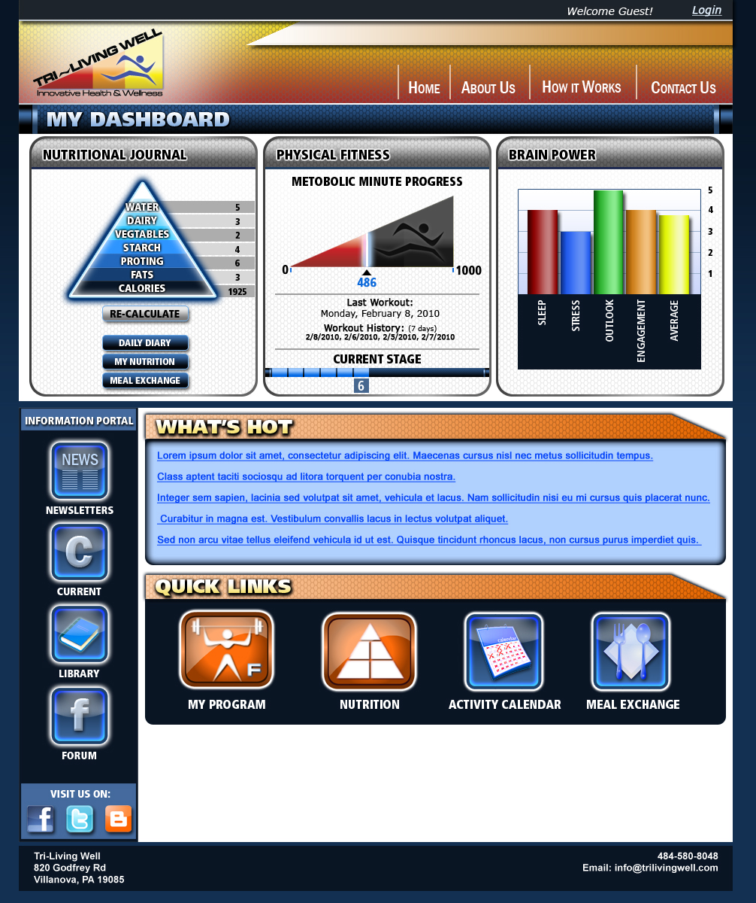

**Appendix C –Risk Classification Pyramid (Step 1, cont’d)**

There are a total of 7 possible risk factors. The number of risk factors can be reduced by one if the user marks YES for having an HDL cholesterol level above 60 mg/dl.

If participant is identified as High Risk, they are instructed to take Framingham Heart Risk Test to evaluate their risk of a heart attack.